**Sandos Medical Services Limited**

**Shops # 4 – 6, Pointe Plaza, Ocho Rios, St. Ann,**

**Jamaica, W.I.**

**P.O. Box 6157, Ocho Rios P.O., St. Ann,**

**Jamaica, W.I.**

**Registration Form**

**Please complete ALL fields.**

**PERSONAL INFORMATION**

**First Name: ____________________ Middle Name: ________________ Last Name: ______________________**

**Gender: Male/Female** **DOB: _______/_______/_______ Age: ______________**

**Address:___________________________________________________________________________________________________________________________________________________________________________________**

**Telephone No.: (cell) _________________ (home) ____________________** **(work) ________________________**

**Email Address**: **_______________________________________________________________________________**

**Place of Employment/School: ___________________________________________________________________**

**Address: _____________________________________________________________________________________**

**Occupation: __________________________________________________________________________________**

**NEXT OF KIN (EMERGENCY CONTACT)**

**First Name:: ___________________________ MI:_______ Last Name:________________________________**

**Relationship:**_______________________ **Email Address:**__________________________________________

**Address:** ___________________________________________________________________________________

**Place of Employment:**________________________________________________________________________

**Telephone No.: (cell)__________________(home)**___________________**(work)**_________________________

**CONDITION INFORMATION**

**CONDITION INFORMATION**

1. **Reason for visit: ___________________________________________**
2. **Date symptoms started?: ___________________________________________**
3. **Getting worse or better?: ___________________________________________**
4. **Rate pain 0-10: ___________________________________________**
5. **Type of pain: sharp / dull / burning / cramping / throbbing**
6. **My pain interferes with: work / sleep / daily routine / recreation**
7. 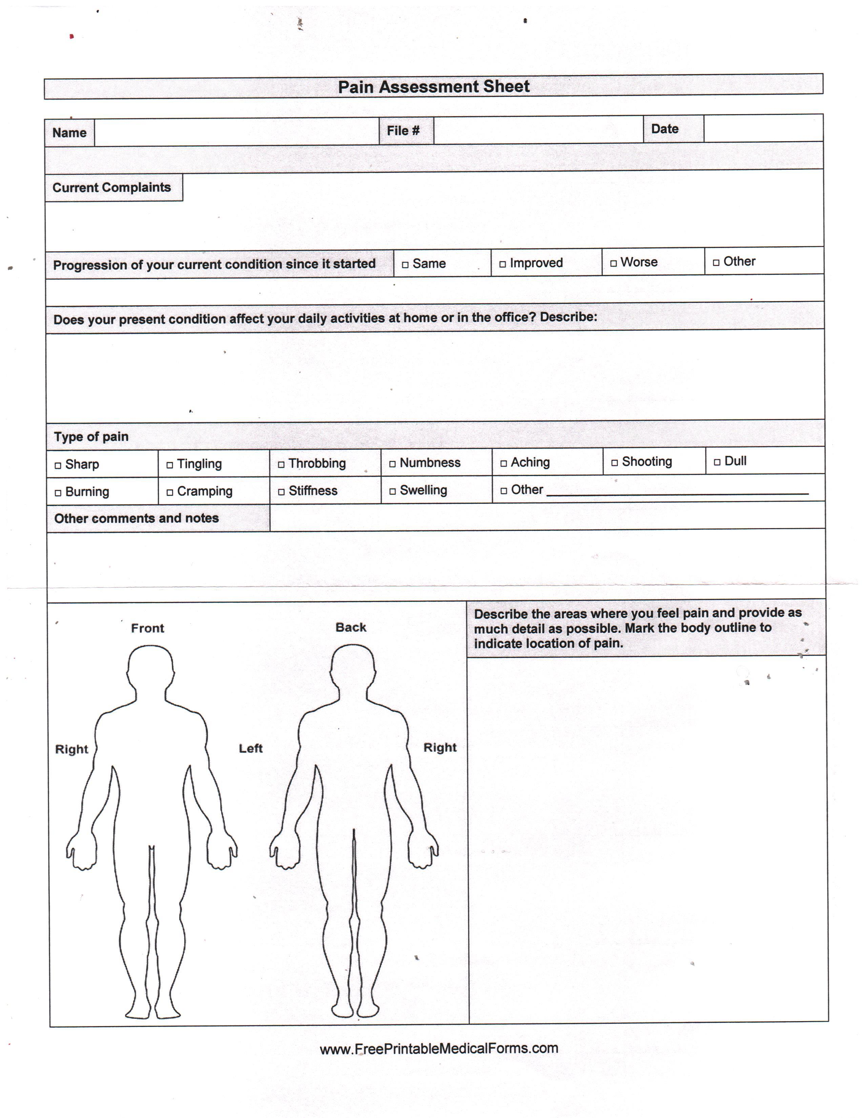**Accident?: Yes / No Type: Motor vehicle/ home / work / other ____________________________**

**PATIENT HISTORY**

**No past Conditions**

Check any condition you are currently being treated for or have had in the past:

* **Neck pain O Anemia or other blood disease**
* **Heart disease O Severe headaches**
* **Back pain O Thyroid disease**
* **Seizures O High blood pressure**
* **High cholesterol O Stroke**
* **Stomach disease O Sleep apnea**
* **Lung disease O Blood clots**
* **Kidney, bladder or prostate disease O Diabetes**
* **Depression O Cancer (past or present)**
* **Other________________________________**

**ALLERGIES (include medication, food, latex and environmental allergies) No Known Allergies**

**Allergy to: 1:________________________ 2.________________________ 3.________________________**

**Severity: Mild Moderate Severe Mild Moderate Severe Mild Moderate Severe**

**Reaction**: ____________________________ __________________________ _________________________

**Please List All Medications, Vitamins, Herbs and Minerals that you are currently taking: ______________________________________________________________________________________________________________________________________________________________________________________**

**No medication**

**PROCEDURES/SURGERIES/HOSPITALIZATION**

1. **Have you ever been hospitalized? Yes/ No If yes, date: _______________**
2. **Have you ever done a surgery or received stitches? Yes/No If yes, date: _______________**
3. **Have had a colonoscopy? Yes/No If yes, date: _______________**
4. **FEMALES: Have you had a mammogram? Yes/No If yes, date: _______________**

**When was your late menstrual cycle? ________________________**

**When did you last have a: 1. Pap Smear: Date: ______________ Not Sure Never**

**2. Breast Check: Date: ______________ Not sure Never**

**OTHER HEALTH ISSUES**

**Do you drink alcohol?__________________ Yes/No Beer Wine Liquor _______ per week**

**Do you smoke cigarettes?_______________ Yes/No If yes, __per day ___ years of use**

**Do you use other forms of tobacco? Yes/No pipe /cigar /snuff/chew**

**Marijuana or recreational drug use? Yes/No If yes,___ per day, _______ years of use**

**IMMUNIZATION**

**Is your immunization up to date? Yes/No**

**Influenza (18 years of age and older)? Yes/No If yes , Date:________________________**

**Pneumococcal (65 years of age and older)? Yes/No If yes, Date: ________________________**

**Tetanus? Yes/No If yes, Date: _________________________**

**PATIENT/GUARDIAN SIGNATURE: _________________________________________________________**

**DATE: ___________________________________**